**DIGITAL MARKETING**

**Assignment1**

|  |  |
| --- | --- |
| **Name** | V.Abinaya |
| **Reg No** | 960220106007 |
| **NM Id** | E78D244BDD69EEBB2E447384319A4008 |
| **Team Id** | NM2023TMID10646 |

1. **Create a blog or website using Blogspot and WordPress. Customize the theme design and post new article with 500 words.**

Blog spot - <https://minbaker.blogspot.com/2023/08/minimalist-baker-introduction.html>

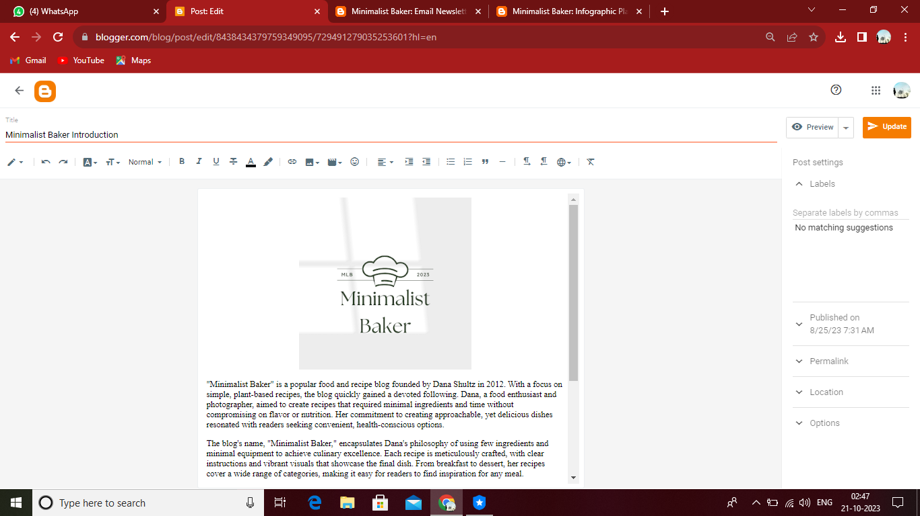

Word press-<https://wordpress.com/home/minimalistbaker3.wordpress.com>

